[](http://www.google.co.uk/url?sa=i&rct=j&q=&esrc=s&source=images&cd=&cad=rja&uact=8&ved=0ahUKEwirvfLUg-_PAhXLVRoKHUSYA_cQjRwIBw&url=http://www.beliefnet.com/columnists/parentingonpurpose/2014/06/tips-on-detaching-from-our-childrens-drama.html&psig=AFQjCNENRD10mPQ49yxOfssRH8DSqm-7nQ&ust=1477246852159799)authoring a website

icons drama

Niall Curley

BMC Consulting

Contents

Functional Specification 3

Purpose 3

Project Description 4

Introduction 4

Goals 4

Target Audience 4

The Environment of the Website 5

HTML5 5

CSS 6

JavaScript 6

Website Requirements 6

Homepage 7

FAQ 7

Contact Us 8

Download Time (speed) 9

Download Speed (Continued) 9

Appropriate URL 10

Homepage Links & Hyperlinks 10

Hyperlinks 11

Links & Colours 11

Two Way Communication 12

Professional Appearance 13

Cascading Style Sheets 14

CSS Properties 15

Search Engine Optimisation 15

Website Accessibility 16

The Design 16

Introduction 16

Research 17

Good Points of this Website 17

Some critical points about this site 18

Dramaworks, 18

Good Points to Website 19

Some criticism of the Website 20

Weighing up 20

Website Design 21

Site Map 21

File Structure Root Folder 22

Storyboards 23

Conclusion 33

Evaluation 33

Interview and Questions (Icons Website) 33

Report 35

Recommended changes 36

Bibliography 37

Web links 37

E- Books 37

## **Functional Specification**

## **Purpose**

This is a document sets out all the requirements for an ecommerce website for a *youth drama school*. It will enable access to information on the school’s activities, services and fees to new potential customers and interested parties.

# **Project Description**

## **Introduction**

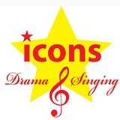This proposed website is for ‘icons drama’, ‘icons’ is a youth drama & singing school that was started in 2007 by Mrs Toni McCann. Toni is a qualified drama teacher who works with youth and children from the ages of 6-14 years of age. Icons work with children of varying abilities to develop their confidence and dramatic abilities through drama and singing. Icons drama presently reside at St Agnes Parish Centre in South West Belfast.

## **Goals**

* To advertise Icons Drama as a business.
* To present clear contact details to user
* To create a quality image for Icons Drama.
* To recruit more students.
* To give parents and students confidence in Icons product.
* To reduce administration.
* To facilitate better financial transactions.
* To create an intuitive website for quick navigation.
* To create a website that will attract multicultural audience.
* To allow Icons personnel to edit the website.

## **Target Audience**

* This website will be designed to *appeal to parents* who are looking for a family safe organization.
* The website should appeal to *youth and children*
* It should be designed to appeal *to parents with children with disabilities*.
* It should *attract Gaelic speakers* of the Gael talk tradition.
* It should appeal to a *multi-cultural audience,* due to the changing ethic demographic.
* The advertised fees should reflect a *working-class area*.
* It should be attractive to *volunteers and prospective employees*.

**Hardware**

* CPU – AMD 1.50 GHz
* RAM – 4 GB
* System – 32-bit x 64 based processors
* Graphics Card – Radeon R2 Graphic
* Hard Drive – Internal 1 TB

**Software**

* Windows 10 Edition
* Adobe Dreamweaver CS6 (or higher)
* Notepad++ v6
* Google Chrome
* MS Word

# **The Environment of the Website**

**HTML5 (hyper-text-mark-up-language, version 5)** – will be used as the language to create this website. It is the most widely used and is supported by most web browsers, used for displaying text, links and images to users.

According to CAZ LTD,[1]

**Why use HTML5 to code your website?**

**Semantic elements**

HTML5 has 'semantic' tags so that you can delineate headers, footers, navigation sections, the main body, articles, miscellaneous sections and so forth. This is useful for both SEO and accessibility reasons in that both search engines and screen readers can make a better analysis of the content. So HTML5 will help towards your search engine results ranking and make it easier for the visually impaired to use your website.

**CSS (Cascading Style Sheets)** – this technology will allow better control of the entire website so that less information will be inputted. The style sheet will control the design style elements throughout all the webpages making it easier for any changes to be consistently implemented throughout the entire site.

**JavaScript** – this simple language will be used to increase the websites interactivity. It doesn’t require constant downloading from your website and is supported by most web browsers.

**According to internet article - quirksmode**[2]

JavaScript is most commonly used as a client side scripting language. This means that JavaScript code is written into an HTML page. When a user requests an HTML page with JavaScript in it, the script is sent to the browser and it's up to the browser to do something with it.

The fact that the script is in the HTML page means that your scripts can be seen and copied by whoever views your page. Nonetheless, to my mind this openness is a great advantage, because the flip side is that you can view, study and use any JavaScript you encounter on the WWW.

# **Website Requirements**

Having carried out an initial interview with our client, the client has specified these ***must have*** **requirements**.

There will be at least ***seven pages*** to the website, three of them being –

* Homepage
* FAQ
* Contact Us

Having discussed with our client who the target audience is, these other pages and should be included.

* Classes
* Events
* Child Protection
* Register
* Disability Friendly
* Work For Us

## **Homepage**

The **Homepage** is the most important feature on this website, it needs to draw your attention to the ‘icons drama’ product on offer, first impressions last and decisions are made in seconds.

According to Jim Thomas, President of Web Concepts.[3]

‘The world may be new to the Internet, but it isn’t new to business. **The Internet acts as a virtual street, with millions of companies and organizations all vying for your business**. Like that window, **a home page is a website’s only chance to show visitors what there is to offer**. A website visitor, like a shopper looking in a window, makes a decision within a very short amount of time whether a website will be any benefit to them.

So if you wouldn’t fill your storefront window with huge advertisements, erroneous announcements, irrelevant news, and anything else not pertaining to your store’s purpose, then why would you do that to your website?’

*This icons homepage will contain* ***only the key information*** *to draw parents, students & youth to the specific activities and information required.*

## **FAQ**

This page will offer the user the ability to gain access to information on icons product without having to contact the organisation directly. A list of well thought through questions will be presented *with answers or links* to resolve these queries, avoiding the need for delay in any return replies and frustration to user.

As Susan Farrell of **NN Group** quotes, [4]

[Frequently Asked Questions](http://www.faqs.org/faqs/faqs/about-faqs/) (*F.A.Q.s, FAQs* or *Q&As*), when done well, deliver a lot of value not only to your website visitor but also to your organization. The FAQ is a mature information format that orginated in 1982 and has evolved along with the Internet, first in email and then in newsgroups. On the web, FAQs continue to improve, with the addition of hypertext links, visual design, databases, and analytics. Encountering familiar tools and structures helps website visitors walk up and use them without having to spend much thought on figuring out how.

If you spend too much time and money on website email or customer-service calls, or if people have questions before they can buy what you’re selling, you might benefit a lot financially by addressing the bulk of those questions in a systematic way on the web.

Each question will be structured in html using the ordered list tag <ol> </ol> and each item listed individually with list item tag <li> </li>.

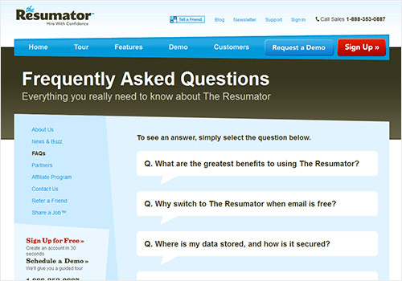

## **Contact Us**

*Contact us* is an important feature on this website, as per Cody of awgadvertising.com; [5]

The first 10 seconds of a page view are when potential customers are most likely to leave a website. In fact, 55 percent of visitors leave websites within 15 seconds of landing on them, according to [Chartbeat](http://time.com/12933/what-you-think-you-know-about-the-web-is-wrong/). What this means is if a potential customer visits your site looking for a phone number or an address, you have the time it takes to skim to the bottom of the page before they move on. Failing to have contact information, or even making it somewhat difficult to find within the site, could cost you vital seconds, and probably a customer.

Our contact details and features will be as follows;

* Name ‘Icons Drama’ – (will be a hyperlink).
* Address (including post codes)
* Opening hours (this will save unnecessary travel to this business)
* Telephone number (including area codes)
* Email address & social media (with a hyperlink)
* Directions (map, this will be an image, <img>)

## **Download Time (speed)**

The customer requires a download time of *three seconds* per page, as per Marcus Taylor of www.ventureharbour.com;[6]

Another way is to use the following guidelines:

Below 1 second = perfect  
1-3 seconds = above average  
3-7 seconds = average  
7+ seconds = very poor

*These benchmarks are based on studies showing that 47% of people expect a web page to load in under two seconds, and 57% of visitors will abandon a page that takes 3 or more seconds to load.*

### **Download Speed (Continued)**

The download speed is related to the loading of *images, CSS Style Sheets, scripts and HTML pages.*

this will be achieved by;

1. Speed & image – images will be compressed and the speed checked using *Googles Page Speed plugin.*
2. Image scaling – images will be scaled with *Photoshop CS6* to suit the same pixel dimensions as the html code. Reducing the length of time, it takes the system to resize them when downloading.
3. CSS style sheets - will be stored in a separate external file, the style sheet file will be downloaded unto the user’s computer once, each time a page is loaded the CSS styles are already there, thus reducing the downloading time.

## **Appropriate URL**

This website will be named appropriately **(http://www.iconsdrama.com)** in line with the product on offer e.g *(the stars and icons of the dramatic world*), this domain name will help users when searching for this type of product and to promote the image and quality of its products.

According to **YOUROWNSITE** – (allaboutyourownwebsite.com);[7]

*- “Professionalism - A website that has a proper website address will look more professional. The business that a website represents will look more competitive with the help of proper website domain name, which is important in building online presence. Because of this, more people will be inclined to do transactions with a website that has a proper website URL”.*

## **Homepage Links & Hyperlinks**

This website will include internal and external hyperlinks such as in the;

* Main navigation – this menu will contain links to access the main pages of the website.
* A homepage link.
* Side menu – a link to email, social media, child protection information, disability information,
* FAQs.
* Paypal – a link to Paypal for course fees.

## **Hyperlinks**

There is a lot of research that proves the importance of hyperlinks within a website, as per Rupaksom (www.worthofweb.com);

“*Search engines also give priority to the sites that have good number of inbound links (hyperlinks) and rank them well. Google has introduced PR rating system only to sort out the sites that have good inbound links and high quality contents. So there is no doubt that hyperlinks play an important role when it comes to SEO”.*

* To connect each page to the homepage, the anchor element will be used. A will be linked created to the Homepage through the <a> and href tags, e.g; **<A HREF="../index.html">**Go to the Home Page**</A>.**
* To create hyperlinks to email and social medial, external hyperlinks will be created e.g; <A HREF = "http://www.google.com/">**Google Search Engine**</A> <A HREF = " https://en-gb.facebook.com/Iconsdrama/” >**Icons Drama Facebook**</A>
* The target attribute will be used to open an external link in a new tab, e.g <A HREF = " https://en-gb.facebook.com/Iconsdrama/” target= “_blank”>**Icons Drama Facebook**</A>

### **Links & Colours**

By using the a:link, a:visited, a:active in the CSS style sheets, all links will be colour coded;

* Links that has not been visited (blue).
* Links that has been visited (purple).
* Link currently in use (red).

e.g

<style>  
a:link    {color:green; background-color:transparent; text-decoration:none}  
 </style>

## **Two Way Communication**

Every business website needs to facilitate customer queries and to reply to them.

As perGhorbani (2014) P.137 argues,[8]

“*One way communication from a website to the consumers that includes broadcasting, emailing, weekly or monthly newsletters, privacy, returns and shipping policies, and frequently asked questions (FAQ) is important but two-way communication between a website and consumer is more important for creating online customer experience. Customers are free to shop online at every hour of a day thus they want to consult sales associates and communicate with the website 24/7. A website should be reachable, to answer question as much as possible.”*

**Registration form** – I will create a form for registering children and students, this will have a check box for choosing the gender of the applicants or whether they are enrolling as a child or as a student volunteer;

Applicants can enter first name, last name, address, postcode, DOB, contact number & email address.

**Two Way Communication (cont)**

**Example of properties of the form;**

<form>  
  First name:<br>  
  <input type="text" name="firstname"><br>  
  Last name:<br>  
  <input type="text" name="lastname">  
</form>

Checkbox e.g - <input type="**checkbox**">

Both forms will also include a *button* for submitting this information.

**Example of submission tag;**

<input type="submit" value="Submit">

**A radio button** - will be used to determine gender of person applying.

e.g

<form>  
  <input type="radio" name="gender" value="male" checked> Male<br>  
  <input type="radio" name="gender" value="female"> Female<br>  
  <input type="radio" name="gender" value="other"> Other  
</form>

**Defaults** - as to where you insert data in the fields & default texts so that only correct data can be inputted, capitals or numerals etc.

### **Professional Appearance**

The pages of the website will be firstly structured using html features (below) and then will be styled using separate CSS file;

<head> </head> (This will contain main title for page and meta information for search engines).

<body> </body> (This will contain must of the other structures),

such as; headers <headers>,

navigation <nav>,

the main content <main>,

the various section of information <section>,

any articles <article>,

paragraphs <p> </p> (all paragraphs will be written between these tags).

<img> (any images will be displayed by this tag).

<form> (this allows for a form to be created for use by a user e.g enrolment).

<a> (inline features will be used through this feature).

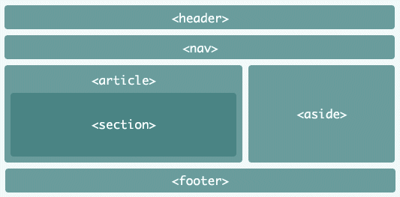

### **Cascading Style Sheets**

I will be using the CSS (styles sheets) to control the websites appearance to a professional standard. Style Sheets allows control over the style of fonts, the colour of text, and background colours. The positioning text through padding, alignment etc.

As quoted by OS Templates,[9]

**Why Use CSS?**

There are extensive arguments to using CSS rather than designing and using tables to layout a website. The main reasons why you should be using Cascading Style Sheets in our opinion are:

1. Cascading Style Sheets allow for a flexible fully controllable website, you can modify the layout of a site with one file. This is cost effective in a commercial perspective.
2. A website that uses CSS allows you to reduce the amount of core code found in your templates, using CSS instead of tables gives you faster loading websites.
3. One of the major plus points to using CSS is for "Accessible" websites. The creation of a website using CSS masters over a table based non-user friendly site
4. Using CSS you can separate the layout from the content improving code to content and improving your chances in the search engines

### **CSS Properties**

* The **float & clear** properties will be used to move various elements; side bars and images to make the element not overlap and the webpage appear balanced.
* The block elements that will contain, headings, paragraphs, links and images will be centred using, **margin : auto;** feature, creating balance in the use of white space.
* The **padding property** will be specified to the required pixels so as to create clear text.
* Border style will be specified, dotted or solid to clearly define header from navigation or content from footer.

e.g **p.solid {border-style: solid;}**

* The colour scheme of the icons drama logo is yellow & red, I will use this logo and these colours in the new design.

## **Search Engine Optimisation**

In the head section of the html document **<meta> tags will be used** to create more visibility within the search engine. This will include;

* ***Keyswords*** that are related to the content of the website, e.g iconsdrama Belfast, drama Belfast, children’s drama in Belfast, singing and dancing etc.
* ***Author*** – a few notes on the author of the site.
* ***Title*** – the title tag <title> will display the title of the main tab.
* ***Content description*** for each website page will be in the head section and will connect with search engine results.

The SEO is a very important way to advertise your website as quote below;[10]- “SEO is fundamentally a set of methodologies that make it easier for search engines to find, include, categorize and rank your web content.”  **– Lee Odden, Online Marketing Blog**

**Site Information**

**A footer section** will be created in the html document and **&copy property** will be used to create the copyright information.

**Authorship** information will be displayed in the footer, promoting the website developer.

# **Website Accessibility**

Aa per - OUT_LAW.COM, [11] - *“The* [*Equality Act 2010*](http://homeoffice.gov.uk/equalities/equality-act/) *(EQA) which came into force in October 2010, replacing the Disability Discrimination Act 1995 (DDA) in England, Scotland and Wales, was introduced with the intention of dealing with the issue of disability discrimination.*

*If your business has a website, it should be accessible to disabled users. There are ethical and commercial justifications for this, but there is also a legal reason: if your website does not meet certain design standards, then you could be sued for discrimination”.*

* To provide accessibility all images will have a **title and alt properties**.
* When the mouse is on the surface of the image a short piece of script will appear describing it.
* A text reader will provide an audio of what the image is.
* Buttons will be large to make them more visible.
* Any text for navigation or links will be underlined.

# **The Design**

## **Introduction**

The purpose of this design specification is to draw up blueprints for the structure of our website. It is a simplistic preview of the website to demonstrate its main structure and its various assets. It takes the requirements of our functional specification, clients requirements and demonstrates how they will be accommodated and set out on our website.

## **Research**

As our client’s business website is a drama school, I have researched similar business websites to observe current designs.

‘**Stagecoach Theatre Arts’**

(http://www.stagecoach.co.uk), is a dramatic business which is trying reach a similar audience.

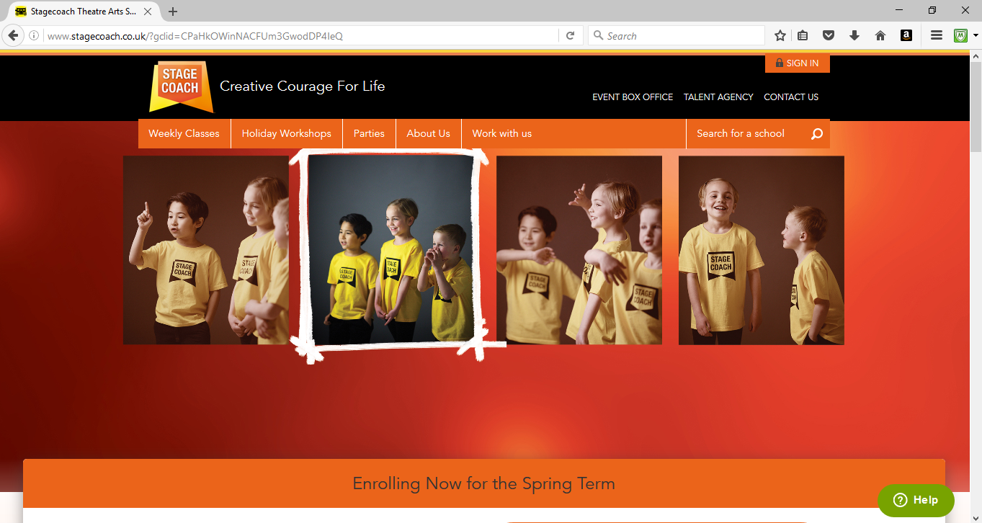

This website is of a very high quality given the area demographic is at the higher end of the market (more expensive fees).

### **Good Points of this Website**

* The use of large bold images to create an inspiring website.
* The webpages colourful are very vibrant with nice contrasts appealing to the eye.
* There are clear choices to access each webpage in the navigation menu.
* The header colour is black causing the ‘STAGECOACH’ logo to stand out.
* Padding keeps the text from the borders of the elements making it easy to read.
* The block elements are well centred and aligned.
* There are clear image hyperlinks to social media.

Below (bottom of Stagecoach Webpage)

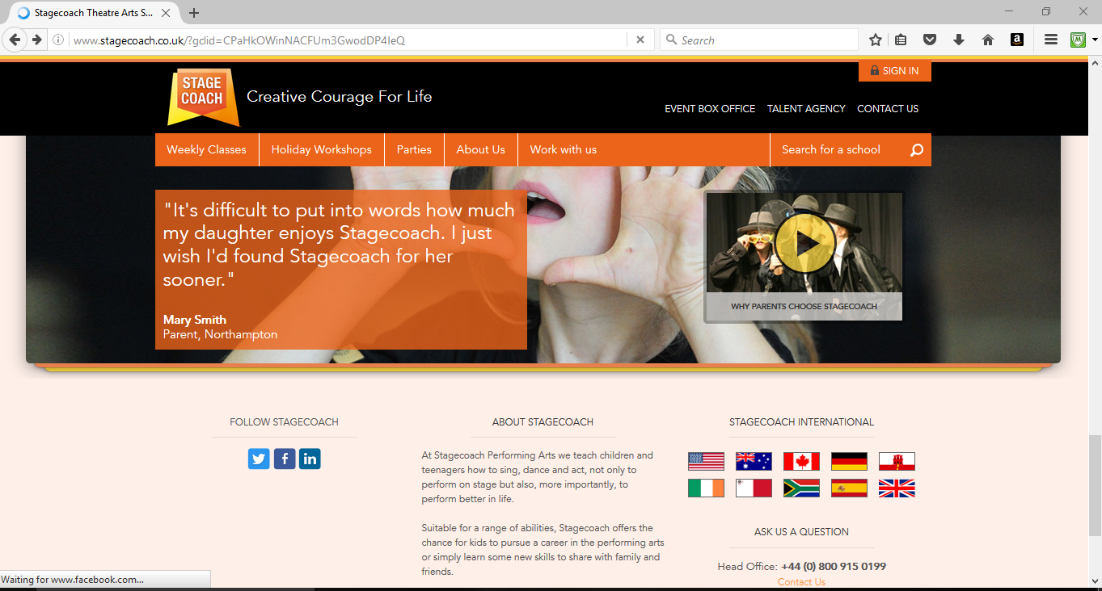

### **Some critical points about this site**

There is just one feature that is slightly off putting about this website, the webpages are quite long and require scrolling, images slide in and out of the frame making it hard to focus.

I think it is best if the proposed website doesn’t have this feature, so the required information will be viewed on a shorter webpage with less or no scrolling.

### **Dramaworks,**

This is another website which is advertising the same services and would have a similar audience.

Top

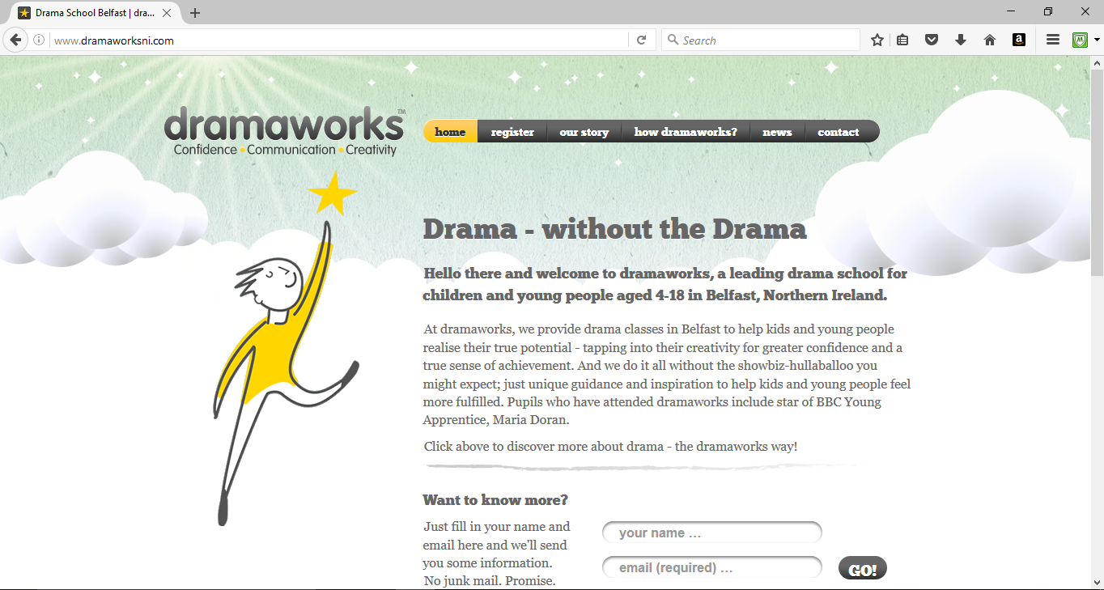

Bottom

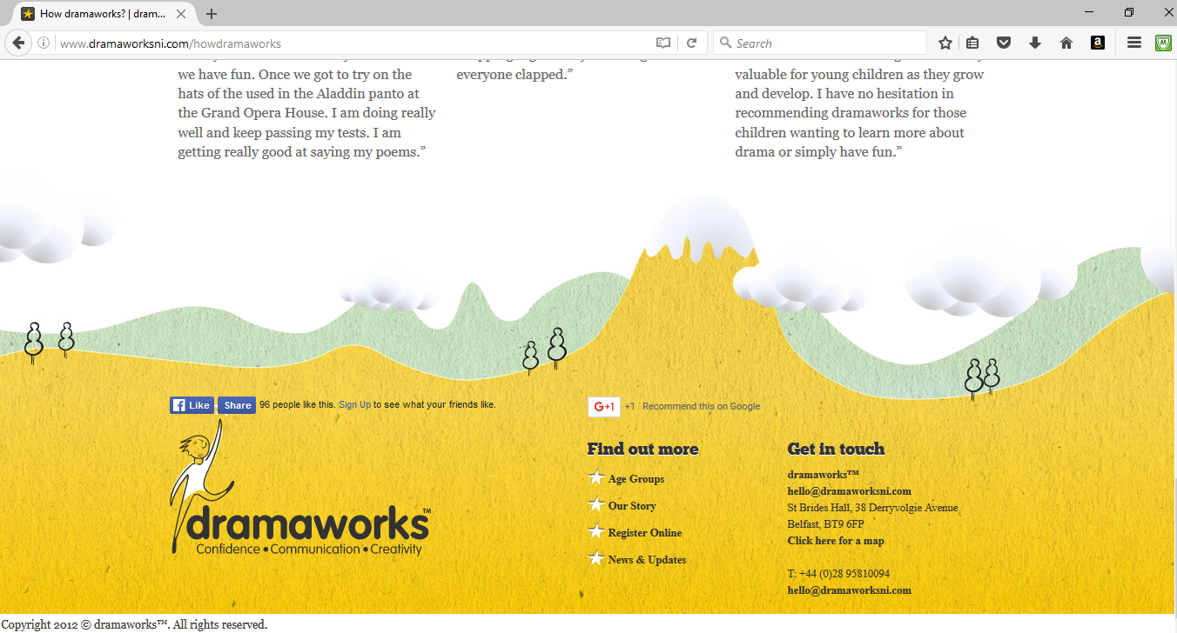

### **Good Points to Website**

* The background and logo of the character reaching for the stars is effective an appropriate.
* The colour of the script and text of the main content of the Homepage is clear and easily readable. The text does not conflict with any other elements.
* The horizontal navigation menu only takes a certain proportion of the webpage; it also has a rounded curved end as it is in proportion to the main content below.
* It has a register feature at the navigation menu.
* All but one of the links are in the side navigation bar at the bottom as are in the main navigation at the top so you don’t have to scroll up again to use them.
* Contact information is easily accessed from navigation.

### **Some criticism of the Website**

The website doesn’t have any images on the Homepage, the colours are quite calm, I think more vibrant colours might create a more living website. There is no mention of child protection on this website or any multicultural images. There is no requests for volunteers or employment with this group, I think it is important to show these features.

**Weighing up** - Taking into consideration both the positive and the negative aspects of both these websites, and the requirements of our client for this website, I will be using;

* inspiring multicultural images
* a clear proportioned navigation menu
* vibrant colours
* ability to register
* child protection images and features
* volunteer features
* social media links.

I think we have the ingredients for a website that will promote the icons product.

# **Website Design**

## **Site Map**

Homepage

Index.html

Classes

classes.html

Child Protection

child_protection.html

FAQ

faq.html

Work/ Volunteer

work_volunteer.html

Disability Friendly

disability_friendly.html

Contact Us

contact_us.html

Register

register.html

Events

events.html

## **File Structure Root Folder**

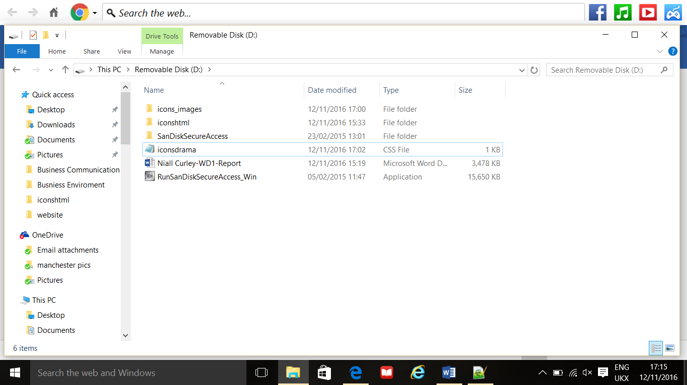

Html Documents (inside within folder)

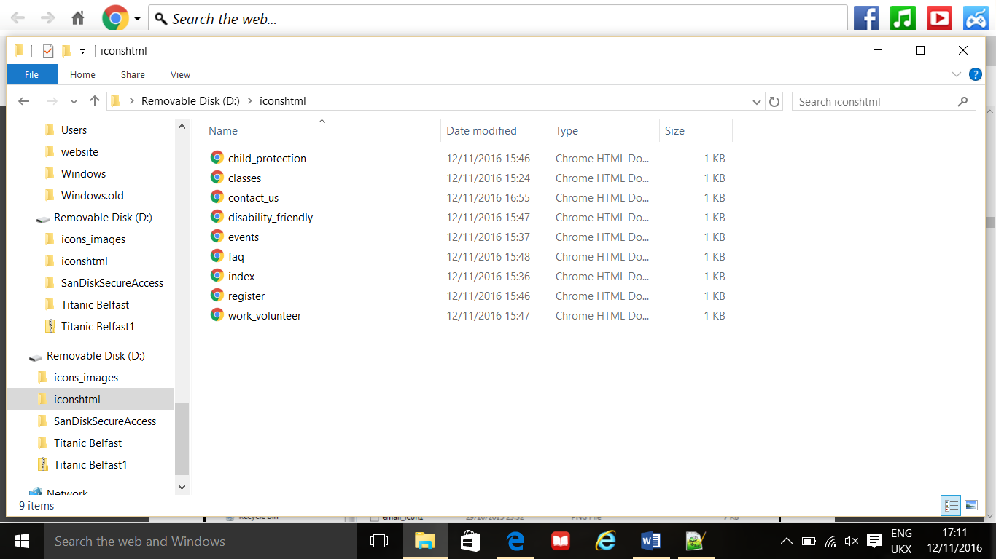

## **Storyboards**

|  |  |  |  |  |
| --- | --- | --- | --- | --- |
| Project Name: Icons Drama Website Date: 12/112016 | | | | |
|  | | | | |
| Page 1 of 9 |  | Template Page Name: index.htmlPage <meta tag> Keywords: icons drama, drama groups, singing lessons, west Belfast drama, icons singing, drama disability friendly, children drama, youth drama, volunteer drama west Belfast, drama confidence building.Page <meta tag> Author: Niall Curley Page <meta tag> Description: This is the Home page of Icons Drama, icons drama is dedicated to teaching children and young people to sing, act and to fulfil their full potential. | | |
|  | | | | |
| |  |  |  |  |  |  | | --- | --- | --- | --- | --- | --- | | <Header><h1>Icons Drama & Singing</h1></header> | | | | | | | Home | Classes | Events | Register | FAQ | Contact Us |   <aside>  <section>   |  | | --- | | <h1>Welcome to Icons Drama & Singing</h1> |   Padding:16px Margin-left: 2cm;   |  |  |  |  | | --- | --- | --- | --- | | <image src | <image src | <image src | <img src |   BG Color:#e65c00  <article>  <p>At icons we are passionate about ….</p>  </article>   |  | | --- | | Disability Friendly | | Work/Volunteer | | Child Protection | | Facebook link | | Twitter link |  <ul> <li><a href=”#”>Link  </a></li>  </ul>  <footer> <small>**&Copyright 2016** <small> </footer>  Footer background: orange, #e65c00; Padding: 16px, margin:1.5cm; | | | | |
|  | | | | |
| Background: Red, #99000Standard Text Properties: Font Style: font-style: normal;  Font Family: Arial, Helvetica;  Font Colour: White, #ffffff;  Link Colour: Blue, #0066ff;  Vlink Colour: Purple, #9900cc;  Hlink Colour: Red, #ff0000; | | |  | Main Task of Page: The home page welcomes visitors to the icons website, it lets the user know about the passion icons has for drama and singing and some its history. |
| Styles/Rules/Scripts**Header Background: black, #000000;** **Navigation & Menu background: orange, #e65c00;**  <nav>  <ul>  <li> <a href=”index.html”>Home</a></li>  </ul> |

|  |  |  |  |  |
| --- | --- | --- | --- | --- |
| Project Name: Icons Drama Website Date: 12/112016 | | | | |
|  | | | | |
| Page 2 of 9 |  | Template Page Name: classes.htmlPage <meta tag> Keywords: icons drama, drama groups, singing lessons, west Belfast drama, icons singing, drama disability friendly, children drama, youth drama, volunteer drama west Belfast, drama confidence building.Page <meta tag> Author: Niall Curley Page <meta tag> Description: This is the Home page of Icons Drama, icons drama is dedicated to teaching children and young people to sing, act and to fulfil their full potential. | | |
|  | | | | |
| |  |  |  |  |  |  | | --- | --- | --- | --- | --- | --- | | <Header><h1>Icons Drama & Singing</h1></header> | | | | | | | Home | Classes | Events | Register | FAQ | Contact Us |   <aside>  <section>   |  | | --- | | <h1>Classes & Information</h1> |   Padding:16px Margin-left: 2cm;  BG Color:#e65c00  <article><h2> Stage 1</h2>  <p>(Information about classes)</p>  <h2>Stage 2 </h2>  <p>(Information about classes)</p> </article>  <img src..>   |  | | --- | | Disability Friendly | | Work/Volunteer | | Child Protection | | Facebook link | | Twitter link |  <ul> <li><a href=”#”>Link  </a></li>  </ul>  <footer> <small>**&Copyright 2016** <small> </footer>  Footer background: orange, #e65c00; Padding: 16px, margin:1.5cm; | | | | |
|  | | | | |
| Background: Red, #99000Standard Text Properties: Font Style: font-style: normal;  Font Family: Arial, Helvetica;  Font Colour: White, #ffffff;  Link Colour: Blue, #0066ff;  Vlink Colour: Purple, #9900cc;  Hlink Colour: Red, #ff0000; | | |  | Main Task of Page: This page will provide information for the user on days, ages and times relating to classes. |
| Styles/Rules/Scripts**Header Background: black, #000000;** **Navigation & Menu background: orange, #e65c00;**  <nav>  <ul>  <li> <a href=”classes.html”>Classes</a></li>  </ul> |
| Project Name: Icons Drama Website Date: 12/112016 | | | | |
|  | | | | |
| Page 3 of 9 |  | Template Page Name: events.htmlPage <meta tag> Keywords: icons drama, drama groups, singing lessons, west Belfast drama, icons singing, drama disability friendly, children drama, youth drama, volunteer drama west Belfast, drama confidence building.Page <meta tag> Author: Niall Curley Page <meta tag> Description: This is the Home page of Icons Drama, icons drama is dedicated to teaching children and young people to sing, act and to fulfil their full potential. | | |
|  | | | | |
| |  |  |  |  |  |  | | --- | --- | --- | --- | --- | --- | | <Header><h1>Icons Drama & Singing</h1></header> | | | | | | | Home | Classes | Events | Register | FAQ | Contact Us |   <aside>  <section>   |  | | --- | | <h1>Icons Events</h1> |   Padding:16px Margin-left: 2cm;  BG Color:#e65c00  <article><h2>Upcoming Events</h2>  <p>What new events are planned</p>  <h2>Previous Events</h2>  <img src….>  <p>Recent events</p></article>   |  | | --- | | Disability Friendly | | Work/Volunteer | | Child Protection | | Facebook link | | Twitter link |  <ul> <li><a href=”#”>Link  </a></li>  </ul>  <footer> <small>**&Copyright 2016** <small> </footer>  Footer background: orange, #e65c00; Padding: 16px, margin:1.5cm; | | | | |
|  | | | | |
| Background: Red, #99000Standard Text Properties: Font Style: font-style: normal;  Font Family: Arial, Helvetica;  Font Colour: White, #ffffff;  Link Colour: Blue, #0066ff;  Vlink Colour: Purple, #9900cc;  Hlink Colour: Red, #ff0000; | | |  | Main Task of Page: This page will display recent events and future events. |
| Styles/Rules/Scripts**Header Background: black, #000000;** **Navigation & Menu background: orange, #e65c00;**  <nav>  <ul>  <li> <a href=”events.html”>Events</a></li>  </ul> |
| Project Name: Icons Drama Website Date: 12/112016 | | | | |
|  | | | | |
| Page 4 of 9 |  | Template Page Name: child_protection.htmlPage <meta tag> Keywords: icons drama, drama groups, singing lessons, west Belfast drama, icons singing, drama disability friendly, children drama, youth drama, volunteer drama west Belfast, drama confidence building.Page <meta tag> Author: Niall Curley Page <meta tag> Description: This is the Home page of Icons Drama, icons drama is dedicated to teaching children and young people to sing, act and to fulfil their full potential. | | |
|  | | | | |
| |  |  |  |  |  |  | | --- | --- | --- | --- | --- | --- | | <Header><h1>Icons Drama & Singing</h1></header> | | | | | | | Home | Classes | Events | Register | FAQ | Contact Us |   <aside>  <section>   |  | | --- | | <h1>Child Protection Information</h1> |   Padding:16px Margin-left: 2cm;  BG Color:#e65c00  <article>  <h2>Our Team</h2>   |  |  |  |  | | --- | --- | --- | --- | | <img src….> | <img src…> | <img src…> | <img src..> |   <li>Names and information about staff and child protection</li>  </article>   |  | | --- | | Disability Friendly | | Work/Volunteer | | Child Protection | | Facebook link | | Twitter link |  <ul> <li><a href=”#”>Link  </a></li>  </ul>  <footer> <small>**&Copyright 2016** <small> </footer>  Footer background: orange, #e65c00; Padding: 16px, margin:1.5cm; | | | | |
|  | | | | |
| Background: Red, #99000Standard Text Properties: Font Style: font-style: normal;  Font Family: Arial, Helvetica;  Font Colour: White, #ffffff;  Link Colour: Blue, #0066ff;  Vlink Colour: Purple, #9900cc;  Hlink Colour: Red, #ff0000; | | |  | Main Task of Page: This webpage will inform users about icons child protection focus. |
| Styles/Rules/Scripts**Header Background: black, #000000;** **Navigation & Menu background: orange, #e65c00;**  <nav>  <ul>  <li> <a href=”child_protection.html”>Child Protecton</a></li>  </ul> |
| Project Name: Icons Drama Website Date: 12/112016 | | | | |
|  | | | | |
| Page 5 of 9 |  | Template Page Name: register.htmlPage <meta tag> Keywords: icons drama, drama groups, singing lessons, west Belfast drama, icons singing, drama disability friendly, children drama, youth drama, volunteer drama west Belfast, drama confidence building.Page <meta tag> Author: Niall Curley Page <meta tag> Description: This is the Home page of Icons Drama, icons drama is dedicated to teaching children and young people to sing, act and to fulfil their full potential. | | |
|  | | | | |
| |  |  |  |  |  |  | | --- | --- | --- | --- | --- | --- | | <Header><h1>Icons Drama & Singing</h1></header> | | | | | | | Home | Classes | Events | Register | FAQ | Contact Us |   <aside>  <section><h1>Registration Form</h1> Padding:16px Margin-left: 2cm;  BG Color:#e65c00  <form>First Name:<input type=”text” name=”firstname”>  <input type=”radio” name=”gender” value=”male” checked>Male  <input type=”radio” name=”status” value=”student” checked>Student  <input type=”radio” name=”status” value=”child”>Child  <p>Course Term Fees - £49.99</p>  <a href = <https://www.paypal.com> **>Link to payment </a>**  </form>   |  | | --- | | Disability Friendly | | Work/Volunteer | | Child Protection | | Facebook link | | Twitter link |  <ul> <li><a href=”#”>Link  </a></li>  </ul>  <footer> <small>**&Copyright 2016** <small> </footer>  Footer background: orange, #e65c00; Padding: 16px, margin:1.5cm; | | | | |
|  | | | | |
| Background: Red, #99000Standard Text Properties: Font Style: font-style: normal;  Font Family: Arial, Helvetica;  Font Colour: White, #ffffff;  Link Colour: Blue, #0066ff;  Vlink Colour: Purple, #9900cc;  Hlink Colour: Red, #ff0000; | | |  | Main Task of Page: To present a form for registration for voluntary staff and child registration for each term & payment of term fees. |
| Styles/Rules/Scripts**Header Background: black, #000000;** **Navigation & Menu background: orange, #e65c00;**  <nav>  <ul>  <li> <a href=”register.html”>Register</a></li>  </ul> |
| Project Name: Icons Drama Website Date: 12/112016 | | | | |
|  | | | | |
| Page 6 of 9 |  | Template Page Name: Contac_Us.htmlPage <meta tag> Keywords: icons drama, drama groups, singing lessons, west Belfast drama, icons singing, drama disability friendly, children drama, youth drama, volunteer drama west Belfast, drama confidence building.Page <meta tag> Author: Niall Curley Page <meta tag> Description: This is the Home page of Icons Drama, icons drama is dedicated to teaching children and young people to sing, act and to fulfil their full potential. | | |
|  | | | | |
| |  |  |  |  |  |  | | --- | --- | --- | --- | --- | --- | | <Header><h1>Icons Drama & Singing</h1></header> | | | | | | | Home | Classes | Events | Register | FAQ | Contact Us |   <aside>  <section>   |  | | --- | | <h1>Contact Us</h1> |   Padding:16px Margin-left: 2cm;  BG Color:#e65c00  <article>  <p>All contact information and opening hours</p>  <img src = “map.jpg”>  </article>   |  | | --- | | Disability Friendly | | Work/Volunteer | | Child Protection | | Facebook link | | Twitter link |  <ul> <li><a href=”#”>Link  </a></li>  </ul>  <footer> <small>**&Copyright 2016** <small> </footer>  Footer background: orange, #e65c00; Padding: 16px, margin:1.5cm; | | | | |
|  | | | | |
| Background: Red, #99000Standard Text Properties: Font Style: font-style: normal;  Font Family: Arial, Helvetica;  Font Colour: White, #ffffff;  Link Colour: Blue, #0066ff;  Vlink Colour: Purple, #9900cc;  Hlink Colour: Red, #ff0000; | | |  | Main Task of Page: The provide the main contact detail of this business, opening hours and give directions to user. |
| Styles/Rules/Scripts**Header Background: black, #000000;** **Navigation & Menu background: orange, #e65c00;**  <nav>  <ul>  <li> <a href=”contact_us.html”>Contact Us</a></li>  </ul> |
| Project Name: Icons Drama Website Date: 12/112016 | | | | |
|  | | | | |
| Page 7 of 9 |  | Template Page Name: disability_friendly.htmlPage <meta tag> Keywords: icons drama, drama groups, singing lessons, west Belfast drama, icons singing, drama disability friendly, children drama, youth drama, volunteer drama west Belfast, drama confidence building.Page <meta tag> Author: Niall Curley Page <meta tag> Description: This is the Home page of Icons Drama, icons drama is dedicated to teaching children and young people to sing, act and to fulfil their full potential. | | |
|  | | | | |
| |  |  |  |  |  |  | | --- | --- | --- | --- | --- | --- | | <Header><h1>Icons Drama & Singing</h1></header> | | | | | | | Home | Classes | Events | Register | FAQ | Contact Us |   <aside>  <section>   |  | | --- | | <h1>Disability Friendly</h1> |   Padding:16px Margin-left: 2cm;  BG Color:#e65c00  <article>  <p>Information on icons relationship with disability organizations</p>  <img src…>  <a href=<http://www.actionforkids.org/>>Action For Kids</a>  </article>   |  | | --- | | Disability Friendly | | Work/Volunteer | | Child Protection | | Facebook link | | Twitter link |  <ul> <li><a href=”#”>Link  </a></li>  </ul>  <footer> <small>**&Copyright 2016** <small> </footer>  Footer background: orange, #e65c00; Padding: 16px, margin:1.5cm; | | | | |
|  | | | | |
| Background: Red, #99000Standard Text Properties: Font Style: font-style: normal;  Font Family: Arial, Helvetica;  Font Colour: White, #ffffff;  Link Colour: Blue, #0066ff;  Vlink Colour: Purple, #9900cc;  Hlink Colour: Red, #ff0000; | | |  | Main Task of Page: This page provides information on how icons offers services to parents of disabled children. |
| Styles/Rules/Scripts**Header Background: black, #000000;** **Navigation & Menu background: orange, #e65c00;**  <nav>  <ul>  <li> <a href=”disability_friendly.html”>Home</a></li>  </ul> |
| Project Name: Icons Drama Website Date: 12/112016 | | | | |
|  | | | | |
| Page 8 of 9 |  | Template Page Name: work_volunteer.htmlPage <meta tag> Keywords: icons drama, drama groups, singing lessons, west Belfast drama, icons singing, drama disability friendly, children drama, youth drama, volunteer drama west Belfast, drama confidence building.Page <meta tag> Author: Niall Curley Page <meta tag> Description: This is the Home page of Icons Drama, icons drama is dedicated to teaching children and young people to sing, act and to fulfil their full potential. | | |
|  | | | | |
| |  |  |  |  |  |  | | --- | --- | --- | --- | --- | --- | | <Header><h1>Icons Drama & Singing</h1></header> | | | | | | | Home | Classes | Events | Register | FAQ | Contact Us |   <aside>  <section>   |  | | --- | | <h1>Work or Volunteer With Us</h1> |   Padding:16px Margin-left: 2cm;  BG Color:#e65c00  <img src..>  Inspiring image of work/volunteers.  <article>  <p>Inspirational section on benefits of working/volunteering for icons</p>  </article>   |  | | --- | | Disability Friendly | | Work/Volunteer | | Child Protection | | Facebook link | | Twitter link |  <ul> <li><a href=”#”>Link  </a></li>  </ul>  <footer> <small>**&Copyright 2016** <small> </footer>  Footer background: orange, #e65c00; Padding: 16px, margin:1.5cm; | | | | |
|  | | | | |
| Background: Red, #99000Standard Text Properties: Font Style: font-style: normal;  Font Family: Arial, Helvetica;  Font Colour: White, #ffffff;  Link Colour: Blue, #0066ff;  Vlink Colour: Purple, #9900cc;  Hlink Colour: Red, #ff0000; | | |  | Main Task of Page: The page provide information for those seeking employment or a voluntary role with icons. |
| Styles/Rules/Scripts**Header Background: black, #000000;** **Navigation & Menu background: orange, #e65c00;**  <nav>  <ul>  <li> <a href=”work_volunteer.html”>Home</a></li>  </ul> |
| Project Name: Icons Drama Website Date: 12/112016 | | | | |
|  | | | | |
| Page 9 of 9 |  | Template Page Name: faq.htmlPage <meta tag> Keywords: icons drama, drama groups, singing lessons, west Belfast drama, icons singing, drama disability friendly, children drama, youth drama, volunteer drama west Belfast, drama confidence building.Page <meta tag> Author: Niall Curley Page <meta tag> Description: This is the Home page of Icons Drama, icons drama is dedicated to teaching children and young people to sing, act and to fulfil their full potential. | | |
|  | | | | |
| |  |  |  |  |  |  | | --- | --- | --- | --- | --- | --- | | <Header><h1>Icons Drama & Singing</h1></header> | | | | | | | Home | Classes | Events | Register | FAQ | Contact Us |   <aside>  <section>   |  | | --- | | <h1>Frequently Asked Questions</h1> |   Padding:16px Margin-left: 2cm;  BG Color:#e65c00  <article> (list of questions and answers)  <p><h3>Q.1 - What is the starting age for new students at icons? </h3><br>  The earliest age is four.  </p>  </article>   |  | | --- | | Disability Friendly | | Work/Volunteer | | Child Protection | | Facebook link | | Twitter link |  <ul> <li><a href=”#”>Link  </a></li>  </ul>  <footer> <small>**&Copyright 2016** <small> </footer>  Footer background: orange, #e65c00; Padding: 16px, margin:1.5cm; | | | | |
|  | | | | |
| Background: Red, #99000Standard Text Properties: Font Style: font-style: normal;  Font Family: Arial, Helvetica;  Font Colour: White, #ffffff;  Link Colour: Blue, #0066ff;  Vlink Colour: Purple, #9900cc;  Hlink Colour: Red, #ff0000; | | |  | Main Task of Page: This page allows the user to ask question and receive answers in written form. |
| Styles/Rules/Scripts**Header Background: black, #000000;** **Navigation & Menu background: orange, #e65c00;**  <nav>  <ul>  <li> <a href=”faq.html”>Home</a></li>  </ul> |

# **Conclusion**

# **Evaluation**

Having initially interviewed the client Mrs Toni McCann regarding the requirements to the above website design. Having produced a functional and design specification to meet these requirements I then arranged to meet with the client and arranged an interview with Michelle McCarthy (a parent of one of the children who attends *icons drama*), to get some feedback to the proposed design. I prepared a list of relevant questions for both interviews.

## **Interview and Questions (Icons Website)**

**Date 5th November 2016**

**Location 35 Ladybook Crescent, Belfast.**

**Time 7.30pm (duration 15 mins).**

**Interviewee one – Mrs Toni McCann (Owner of Icons Drama).**

**Q.1 What is your initial impressions of the proposed design of the website, are you impressed or not?**

“Yes, I liked it when I first looked at your design, all the navigation areas seem clear enough and easy to see. There should be no problem knowing where everything will be. The positioning of pictures (images) and the information (text) should work well”.

**Q.2 What do you think of the navigation areas, are they sufficient?**

“Yes, I think all the different options meet my requirements. The navigation menu opens all the different pages that I wanted”.

**Q.3 Does the website meet the needs for the target audience?**

“It seems to, the child protection section is great, and should give parents confidence in our organization, the work/volunteer section should attract students doing the teacher training in St Marys teacher training College. The disability section should give us the edge in the market as most other organization don’t accommodate for this. One criticism is that I don’t see much on the website about multiculturalism”.

**Q.4 Are the choice of colours correct, can you suggest any improvements?**

I like the orange colour used in the top part where you click (navigation areas), it should stand out well against the wine colour for the background. Im not sure if I liked the black colour in the top area (header), maybe it could be more neutral, im not sure”.

**Q.5 Is the proposed number and positioning of the images correct?**

“I like the positioning of the images but I think there could be more, and they could be bigger, particularly multicultural ones”.

**Q.6 Is the proposed registration form adequate?**

“I think combining the two forms into one is a good idea, and the little check boxes should make things easier for enrolment and for the student applications”.

**Q.7 Are the links to social media and the connections charitable organizations presented properly and easy to access?**

“Yes, I think it will be easy enough to link to our Facebook page and our affiliated disability groups, it might be better to put in some little symbols for Facebook and Twitter, it looks better”.

**Date 9th November 2016**

**Location 21 Lagmore Dale, Dunmurry, Belfast.**

**Time 7.00pm (duration 15 mins).**

**Interviewee two – Mrs Michelle McCarthy (Child attends Icons Drama).**

**Q.1 What is your initial impressions of the proposed design of the website, are you impressed or not?**

“Very good indeed, colourful, it will look very well, when its completed. All the main things that a parent is looking for in a professional looking organization”.

**Q.2 What do you think of the navigation areas, are they sufficient?**

“They look good and clear, all organized and laid out well, I think that the disability part may be better at the top part (navigation) rather than the side”.

**Q.3 Does the website meet the needs for the target audience?**

“There is a load of different things in this website that will draw parents to enrol their kids, the child protection is very important today and so is the disability parts, the different ages groups and volunteering bit for students is good too”.

**Q.4 Are the choice of colours correct, can you suggest any improvements?**

“Your choice of colours in the background and the top and bottom bars (navigation & footer) part are good, they make it look new and fresh, you could do possibly something to make the borders standout more”.

**Q.5 Is the proposed number and positioning of the images correct?**

“I love images in websites but sometime they go over the top, I think you might need one in the disability page, one that appropriate”.

**Q.6 Is the proposed registration form adequate?**

“I think it is good to be able to enrol our children and pay the fees for the term. I think you might need the form to receive information about the parent of the child”.

**Q.7 Are the links to social media and the connections charitable organizations presented properly and easy to access?**

“They are good and be easily seen, especially the disability links, it will give parents confidence that you will look after their kids and try hard for them”.

## **Report**

Having considered the initial interview and two subsequent interviews with client user and parent user. I will now summarize the main points as to the strengths, weakness and proposed improvements to the design of our website.

The initial interview with my client gave me the main requirements, which I have tried to follow. However having got feedback from my client and also a parents view of the design of my website, it has now confirmed and also caused me to re-evaluate some of my design.

The use of Google Chrome as my web browser has been the right one as it is one of the most universally used web browser and accepts most types of coding.

The use of CSS (style sheets) was very useful in setting the styling most of the features of my website design. It has been useful in keeping everything from fonts, font style, font family consistent and professional.

Both interviewees seemed to think that the proposed design was well laid out, colourful, in proportion and professional looking. They both said that the navigation area was clear enough and easy to find, but Michelle (parent) thought the disability section might be better in the top (navigation) rather than the side bar. I think this would work too.

The target audience was is mainly parents of children looking for a quality organization to teach their children drama, I this has been achieved by the acceptance of different age groups, disability friendly feature and links with organizations, child protection emphasis and volunteer recruitment. However there was one observation by client (Toni McCann), that there needed to be multicultural images included.

The visual side of the site as seen in the use of bright colours was generally good, the vibrant red and the orange colours for the navigation, footer and aside were acceptable to client and parent. However, client (Toni McCann) did mention that header colour was too dark and parent (Michelle) thought that the borders of the navigation, footer and aside should be more defined to stand out.

The client (Toni McCann) thought that the positioning of the images were good, but said there should be more. Michelle (parent) commented that the images were ok but there should be room for an image in the disability section. I had felt there was enough information in that section with text and links, however this will be looked at.

The forms for the registration generally got good feedback as they covered the requirements with a combination form with checkboxes and links to PayPal. Michelle (parent) said it would be better if there was a section in the form for the parents to enter their name and contact number for icons records. This was something I had overlooked.

The use of social media links works well for the client as she has a Facebook to promoter her business, she is happy with the disability links as well. Michelle parent thought that these links were easy enough to use but thought it would be better if the Facebook link was an icon.

## **Recommended changes**

I will implement the following changes in my design;

The disability page will be moved into the top navigation to replace the FAQ section; the FAQ page will be moved to the side bar.

I will add more images with a multicultural feel and have a sensitive disability image on the disability friendly page along with links to these organizations.

The colour of the header will be changed to a lighter blue colour, #000085 in line with client requirements. The borders of the navigation, footer and aside bar will be more defined.

I will enter some more fields to the registration form for parents to enter their name and contact telephone number.

The Facebook link will have an <img link instead of a text link. This will look better and require the image to be stored in a separate folder.

Generally I think the project has gone well given this is my first one.

# **Bibliography**

### **Web links**

* CODY AWG - <http://awgadvertising.com/the-importance-of-a-contact-us-page/> - [Accessed 5.11.2016].
* CAZ LTD 2016 - [http://www.caz.ltd.uk/articles/why-use-html5 - accessed 1.11.2016](http://www.caz.ltd.uk/articles/why-use-html5%20-%20accessed%201.11.2016). [Accessed 6.11.2016].
* LEE ODDIN - <http://magnetsites.com/top-20-inspirational-seo-quotes-time/> - [Accessed 6.11.2016].
* Off Com - - <https://www.ofcom.org.uk/about-ofcom/latest/media/media-releases/2014/3g-4g-bb-speeds> – [Accessed 25.10.2016]..
* OUT-LAW - <http://www.out-law.com/page-330> [Accessed 8.11.2106].
* OS Template - <http://www.os-templates.com/journal/cascading-style-sheets/why-use-css> - [Accessed 1.11.2016].
* RUPAKSOM - <http://www.worthofweb.com/blog/what-are-hyperlinks-and-why-ar0000000e-they-important-for-seo/> - [Accessed 5.11.2016].
* Susan Farrell – NN Group.Com – <https://www.nngroup.com/articles/faqs-deliver-value/> [Accessed 29.10.2016]
* MARCUS TAYLOR - <https://www.ventureharbour.com/improving-site-speed/> - [Accessed 5.11.2016].
* JIM THOMAS - http://www.keywebconcepts.com/blog/2010/08/16/the-importance-of-your-sites-homepage/ - [ Accessed 29.10.2016]
* Quirksmode - [http://www.quirksmode.org/js/intro.html - accessed 1.11.2016](http://www.quirksmode.org/js/intro.html%20-%20accessed%201.11.2016).
* YOUROWNSITE – allaboutyourownwebsite.com – [Accessed 5.11.2016].

### **E- Books**

* GHORBANI, A (2014) *Marketing in the Cyber Era: Strategies and Emerging Trends.* 1st Edition. United States of America: Business Science Reference.

1. CAZ LTD UK
2. QUIRKS MODE
3. Jim Thomas (President Key Web Concepts).
4. Susan Farrell (NN Group)
5. CODY AWG
6. MARCUS TAYLOR (VENTURE HARBOUR)
7. YOUROWNSITE
8. GHORBANI (Marketing in the Cyber Era)
9. OS TEMPLATES
10. LEE ODIN
11. OUT-LAW.COM